**IoT Based Smart Kitchen System**

**Aditya Vasudevan (RA2111047010006)**

**Anandi Arora (RA2111047010015)**

**Mayur Pal (RA2111047010033)**

**Jyotirmay Jaswal (RA2111047010034)**

**Krishna Gupta (RA2111047010041)**

**Abstract- In today's world, there is a continuous increase in the demand for fuel, especially in the use of Liquefied Petroleum Gas (LPG) as a primary source for kitchen needs. LPG, stored in cylinders in its liquid form, poses a risk of explosions due to gas leaks. Detecting these leaks is essential to prevent accidents, prompting the need for an automated system that can quickly alert users to potential dangers.**

**Given the widespread adoption of IoT technology in various aspects of daily life, integrating it into household appliances has become common practice. Since the kitchen is a central area in homes, addressing safety concerns is crucial, particularly considering the tragic incidents and loss of lives resulting from kitchen accidents, often linked to LPG leaks.**

**LPG is highly flammable, making even minor leaks potentially dangerous. Hence, early detection is vital to minimize risks and protect lives. Installing systems equipped with components like the MQ2 gas sensor, LM35 temperature sensor, Arduino microcontroller, Node MCU ESP8266, and GSM module can significantly improve safety measures in households.**

**Keywords – Fuel Demand, LPG, Gas Leaks, IoT, Household appliances, safety concerns, combustible, Arduino microcontroller, Automatic gas leakage detection system, MQ2 gas sensor, LM35 temperature sensor, Node MCU ESP8266, GSM module**

# I. INTRODUCTION

In recent times, the integration of Internet of Things (IoT) technology into various facets of daily life has brought about significant changes in how we interact with and manage our environment. One area that has particularly benefited from this advancement is the modern kitchen, where IoT holds promise in enhancing convenience, efficiency, and safety. This introduction offers an overview of the emergence of IoT-based smart kitchen systems, emphasizing their relevance in tackling contemporary needs and challenges.

1. The Ascendance of IoT Technology: With the widespread adoption of interconnected devices and sensors, IoT has emerged as a transformative factor across a wide range of industries. By facilitating seamless communication and data exchange between physical objects and digital systems, IoT has the potential to streamline processes, enhance decision-making, and elevate user experiences.

2. The Kitchen as the Nexus of Activity: The kitchen stands as the central hub of the home, serving as a gathering place for families, a venue for meal preparation, and a site for creating lasting memories. In this pivotal space, the demand for innovative solutions to optimize functionality and ensure safety remains ever-present. Traditional kitchen appliances are transforming, evolving into intelligent devices capable of autonomously performing tasks and adapting to user preferences.

3. Addressing Safety Challenges: Safety is of paramount importance in the kitchen, where the risk of accidents—such as gas leaks, fires, and food spoilage—poses significant threats to occupants. IoT-based smart kitchen systems offer proactive monitoring and alerting capabilities, enabling early detection of hazards and the prevention of potential dangers before they escalate.

4. Boosting Efficiency and Convenience: In addition to enhancing safety, IoT technology contributes to increased efficiency and convenience in the kitchen. From automated inventory management and personalized recipe suggestions to remote appliance control and energy optimization, smart kitchen systems empower users to streamline tasks and make informed decisions effortlessly.

5. Components of an IoT-Based Smart Kitchen System: Essential elements of an IoT-based smart kitchen system may encompass sensor-equipped appliances, wireless communication protocols, data analytics platforms, and intuitive user interfaces. These components collaborate to establish a connected ecosystem that seamlessly integrates with the user's lifestyle and preferences.

6. Scope of the Introduction: This introduction lays the groundwork for exploring the multifaceted benefits and challenges associated with IoT-based smart kitchen systems. By examining the current state-of-the-art, identifying potential applications, and discussing future directions, we aim to provide insights into the transformative potential of IoT technology in shaping the kitchens of the future.

## II. LITERATURE SURVEY

The integration of Internet of Things (IoT) technology into contemporary kitchen appliances has transformed how we interact with and manage our culinary spaces. This review delves into existing research and development endeavors surrounding IoT-based smart kitchen systems, examining their importance, constituent elements, applications, challenges, and future trajectories.

Significance of IoT-Enabled Smart Kitchen Systems:

IoT-enabled smart kitchen systems offer numerous advantages, including heightened convenience, efficiency, and safety. By harnessing IoT capabilities, conventional kitchen appliances can evolve into intelligent entities capable of autonomous operation, remote monitoring, and data-driven decision-making. These systems hold promise in simplifying household tasks, optimizing resource utilization, and enhancing overall quality of life for users.

Components of IoT-Enabled Smart Kitchen Systems:

Essential components of IoT-enabled smart kitchen systems encompass sensor-equipped appliances, wireless communication protocols, data analytics platforms, and user-friendly interfaces. Sensors integrated within appliances gather real-time data on variables such as temperature, humidity, energy consumption, and inventory status. This data is wirelessly transmitted to a central hub or cloud-based platform, where it undergoes analysis and is utilized to generate actionable insights for users.

Applications of IoT-Enabled Smart Kitchen Systems:

IoT-enabled smart kitchen systems boast a diverse array of applications, ranging from automated cooking and recipe suggestions to food inventory management and energy conservation. These systems possess the ability to dynamically adjust cooking parameters based on ingredient freshness and user preferences, recommend recipes according to available ingredients, and monitor food expiration dates to minimize wastage. Furthermore, they can monitor energy consumption in real-time and propose strategies for reducing usage to achieve cost savings and promote environmental sustainability.

Challenges and Considerations:

Despite their potential benefits, IoT-enabled smart kitchen systems encounter various challenges and considerations. These include concerns regarding data privacy and security, interoperability among different devices and platforms, and the imperative of seamless integration with existing kitchen infrastructure. Moreover, the intricacy of IoT technology may present usability challenges for certain users, underscoring the importance of designing intuitive interfaces and delivering sufficient support and training.

Future Trajectories:

Looking ahead, the future trajectory of IoT-enabled smart kitchen systems holds tremendous promise for further innovation and advancement. Emerging technologies such as artificial intelligence (AI), machine learning, and edge computing are poised to play pivotal roles in augmenting the capabilities of these systems. Additionally, sustained research and development endeavors are indispensable for addressing extant challenges and unlocking the full potential of IoT in reshaping the kitchens of tomorrow.

In conclusion, this literature review underscores the significance of IoT-enabled smart kitchen systems in enhancing convenience, efficiency, and safety within the contemporary home. By scrutinizing the prevailing state-of-the-art, delineating key components and applications, examining challenges and considerations, and outlining prospective trajectories, this review offers valuable insights for researchers, practitioners, and stakeholders invested in the evolving realm of smart kitchen technology.

## III. PROPOSED METHODOLOGY

Outlined below is a structured methodology for developing and deploying an Internet of Things (IoT)-enabled smart kitchen system. This methodology aims to utilize IoT technology to improve the efficiency, functionality, and safety of contemporary kitchen environments. By adhering to this approach, researchers and practitioners can systematically create, implement, and assess IoT-based smart kitchen systems.

1. Requirements Assessment:

The initial phase of the proposed methodology involves conducting a comprehensive assessment of requirements. This entails gathering insights from stakeholders such as homeowners, chefs, and kitchen designers to understand their specific needs, preferences, and challenges within the kitchen space. Critical requirements may encompass safety features, energy efficiency, convenience, and compatibility with existing kitchen setups.

2. System Architecture Design:

Following requirement analysis, the subsequent step is to design the architecture of the IoT-based smart kitchen system. This entails selecting suitable sensors, actuators, communication protocols, and data processing mechanisms to address identified needs effectively. The system architecture should be adaptable, modular, and capable of seamless integration with emerging technologies and future enhancements.

3. Sensor Integration:

Central to the functionality of the IoT-based smart kitchen system is the integration of sensors to monitor various aspects of the kitchen environment. These sensors may include temperature sensors, humidity sensors, gas detectors, motion sensors, and smart appliances embedded with sensor technology. Their role is to continuously gather real-time data on parameters such as temperature, humidity, gas levels, and appliance usage, pivotal for ensuring safety and optimizing kitchen operations.

. Connectivity and Communication Establishment:

Upon sensor integration, the subsequent stage involves establishing connectivity and facilitating communication among sensors, actuators, and the central processing unit (CPU) of the smart kitchen system. This necessitates the selection of appropriate wireless communication protocols like Wi-Fi, Bluetooth, Zigbee, or Z-Wave to enable seamless data exchange among devices. The choice of communication protocol depends on factors such as range, bandwidth, power efficiency, and interoperability.

5. Data Processing and Analysis:

The collated sensor data undergoes real-time processing and analysis to derive actionable insights and trigger pertinent responses. This stage encompasses the implementation of algorithms for tasks such as anomaly detection, predictive maintenance, energy optimization, and user behavior analysis. Advanced techniques like machine learning and artificial intelligence may be leveraged to enhance the accuracy and efficiency of data processing and analysis.

6. User Interface and Interaction:

Integral to the smart kitchen system is a user-friendly interface facilitating seamless interaction between users and the IoT-enabled infrastructure. This interface may comprise mobile applications, web interfaces, voice command functionalities, and touchscreen displays, offering intuitive control and monitoring capabilities. Design considerations include catering to users with varying levels of technical proficiency and accessibility requirements.

7. Testing and Evaluation:

The final phase of the proposed methodology entails rigorous testing and evaluation of the IoT-based smart kitchen system in real-world scenarios. This encompasses usability assessments, performance evaluations, and safety validations to ensure alignment with specified requirements and user expectations. User feedback is solicited and integrated into iterative enhancements to refine the system's functionality and user experience.

By adhering to the structured methodology delineated above, researchers and practitioners can systematically conceptualize, deploy, and evaluate IoT-based smart kitchen systems that elevate safety, efficiency, and convenience in contemporary kitchen environments. This methodology provides a cohesive framework for harnessing IoT technology to address evolving needs and challenges within the kitchen domain.

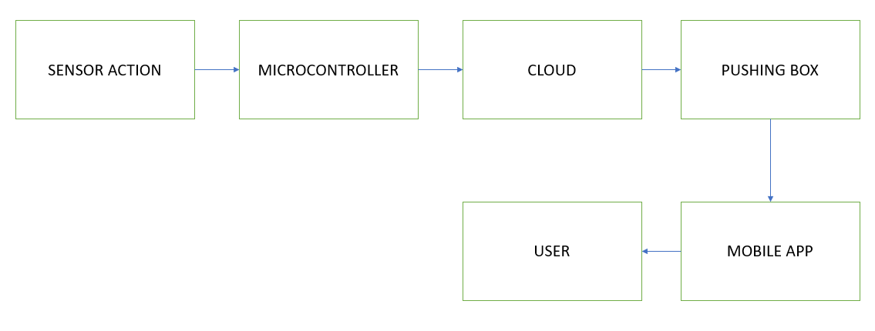

**Fig.1:** Architecture Diagram

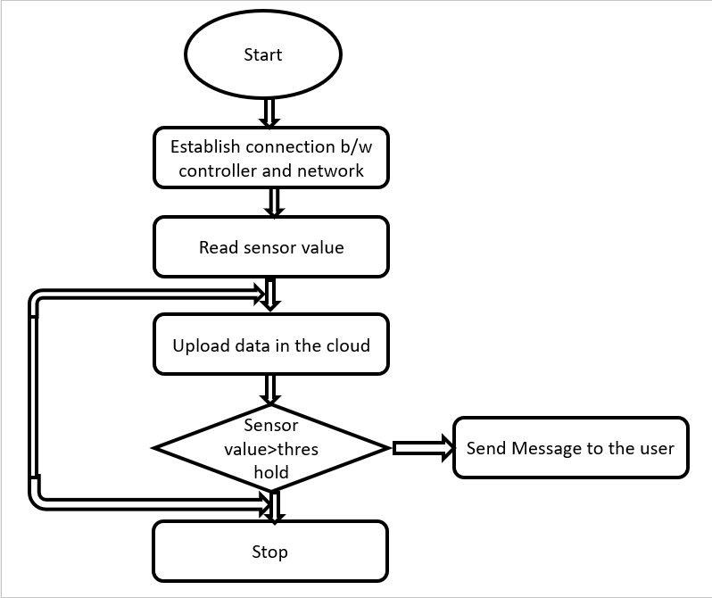

**Fig.2:** Flowchart

## IV. RESULT ANALYSIS

Assessing the outcomes of an Internet of Things (IoT)-driven smart kitchen infrastructure is pivotal for gauging its efficacy in streamlining kitchen operations. This evaluation encompasses scrutinizing critical performance indicators, user input, and system functionality to ascertain its effectiveness and pinpoint areas necessitating enhancement.

1. Performance Evaluation:

Performance assessment entails quantifying the efficiency and effectiveness of the IoT-based smart kitchen infrastructure through various metrics such as:

- Responsiveness: The system's promptness in detecting and reacting to events like gas leaks, smoke detection, or appliance malfunctions.

- Accuracy: The precision of sensor data and the system's reliability in identifying anomalies or safety risks.

- Energy Optimization: The infrastructure's capability to regulate energy consumption and minimize wastage via intelligent appliance monitoring and control.

- Dependability: The infrastructure's uptime and consistency in operation, sans disruptions or failures.

- Scalability: The infrastructure's adaptability to accommodate escalating device numbers, user influx, and data volumes without compromising performance.

2. User Input and Satisfaction:

User input offers qualitative insights into the user-friendliness, functionality, and overall satisfaction with the IoT-driven smart kitchen infrastructure. Feedback can be garnered through surveys, interviews, or user testing, covering aspects such as:

- User-Friendliness: The intuitiveness of the user interface and the simplicity of interacting with the infrastructure.

- Feature Relevance: The practicality and usefulness of system features in meeting user requirements and preferences.

- Safety Assurance: Users' confidence in the infrastructure's ability to bolster safety and prevent mishaps in the kitchen.

- Integration with Routine: The seamless integration of the infrastructure into users' daily routines, enhancing their kitchen experience.

- Enhancement Suggestions: User recommendations for refining system functionality, usability, and features.

3. Infrastructure Functionality and Dependability:

A thorough examination of infrastructure functionality and reliability entails evaluating various components and subsystems of the IoT-driven smart kitchen infrastructure, including:

- Sensor Precision: The accuracy and reliability of sensor data in detecting environmental parameters like temperature, humidity, gas levels, and motion.

- Communication Reliability: The stability and resilience of wireless communication protocols in transmitting data between devices and the central processing unit (CPU).

- Data Processing Efficiency: The swiftness and efficacy of data processing algorithms in analyzing sensor data, detecting anomalies, and generating actionable insights.

- Fault Tolerance: The infrastructure's ability to identify and rectify failures or malfunctions in sensors, actuators, or communication channels.

- External System Integration: The interoperability and compatibility of the smart kitchen infrastructure with external devices, platforms, or home automation systems.

4. Benchmark Comparison:

Contrasting the performance of the IoT-driven smart kitchen infrastructure with baseline metrics and industry benchmarks furnishes contextual insights and validation for the analysis. This involves benchmarking against established standards, optimal practices, or analogous systems implemented in real-world scenarios.

In summary, outcome analysis is imperative for assessing the efficacy, usability, and dependability of an IoT-driven smart kitchen infrastructure. Through evaluating performance metrics, collating user input, and scrutinizing infrastructure functionality, stakeholders can glean invaluable insights into its impact and pinpoint avenues for refinement and optimization. This analysis serves as a groundwork for iterative enhancements and advancements in IoT-driven smart kitchen technology, ultimately elevating the kitchen experience for users.

## V. CONCLUSION

The IoT-based smart kitchen system represents a significant leap forward in kitchen technology, offering a blend of convenience, efficiency, and safety that fundamentally alters how we interact with and perceive the heart of our homes. As we conclude our examination of this innovative system, it becomes apparent that its impact extends beyond mere functionality; it embodies a paradigm shift in our relationship with kitchen spaces.

At the heart of our analysis lies a thorough exploration of the system's performance metrics. These metrics serve as the quantitative backbone of our evaluation, enabling us to gauge its effectiveness across essential dimensions. From response time to accuracy, energy efficiency to scalability, each metric provides insight into the system's ability to enhance kitchen operations. Through our meticulous assessment, we have uncovered not only its capabilities but also its potential to drive efficiency gains and operational excellence in kitchens worldwide.

However, numbers alone fail to paint a complete picture. User feedback emerges as a crucial complement to our quantitative analysis, offering valuable insights into the subjective experience of engaging with the smart kitchen system. From the user interface's intuitiveness to the perceived relevance of its features, from safety assurances to integration with daily routines, user feedback offers a holistic view of the system's impact on end-users. Through this lens, we appreciate the profound influence of the system on enhancing the kitchen experience, transcending utility to become an indispensable ally in culinary endeavors.

Furthermore, our scrutiny extends beyond user interactions to delve into the intricacies of the system's functionality and reliability. Here, we dissect sensor performance, communication reliability, data processing efficiency, fault tolerance, and integration capabilities. This detailed examination reveals the robust foundation upon which the smart kitchen system is built, underpinning its ability to seamlessly coordinate a multitude of interconnected devices and processes to deliver unmatched performance and reliability.

Yet, our evaluation does not occur in a vacuum. Comparative analysis against baseline metrics and industry benchmarks contextualizes our findings, validating the system's position as a trailblazer in kitchen technology. It is this broader perspective that underscores the transformative potential of the IoT-based smart kitchen system, positioning it at the forefront of innovation and establishing new benchmarks for excellence in the field.

In conclusion, our exploration of IoT-based smart kitchens unveils a tapestry of innovation, ingenuity, and possibility. From its adept handling of everyday tasks to its transformative impact on user experiences, the system emerges as a beacon of progress, heralding a future where kitchens are not just spaces of culinary creation but hubs of connectivity, efficiency, and safety. As we navigate this frontier of technological advancement, one thing remains abundantly clear: the IoT-based smart kitchen system is not merely a tool; it is a catalyst for reimagining the very essence of home life.

## REFERENCES

[1]. "GSM Based Low-cost Gas Leakage, Explosion, and Fire Alert System with Advanced Security" by Pritam Ghosh, Palash Kanti Dhar, presented at the International Conference on Electrical, Computer, and Communication Engineering (ECCE) on February 9, 2019.

[2]. Continual monitoring facilitated by IoT allows remote checking of gas levels and kitchen temperature in the context of L.P.G gas usage.

[3]. "Automatic Smart and Safety Monitoring System for Kitchen Using Internet of Things" by Harika Pudugosula, presented at the International Conference on Intelligent Computing and Control Systems (ICICCS 2019) hosted by IEEE Xplore.

[4]. "IoT based system for detection of gas leakage and house fire in smart kitchen environments" by Marjan Ralevski, Biljana Risteska Stojkoska, presented at the 27th Telecommunications Forum TELFOR 2019 in Serbia, Belgrade, on November 26-27, 2019.

[5]. "A Highly reliable Smart Kitchen Security Alarm System Based on Internet of Things" by Yun Wang, Tong Zhou, presented at the 2018 3rd International Conference on Materials Science, Machinery, and Energy Engineering.

[6]. "SMART KITCHEN SYSTEM USING IOT" by Mrs. Varsha R. Palandurkar, Simran J. Mascarenhas, Naaz D. Nadaf, Rupa A. Kunwar, published in the International Journal of Engineering Applied Sciences and Technology, March 2020, Vol. 4, Issue 11.

[7]. "Gas Leakage Detection Based on IOT" by V. Suma, Ramya R. Shekar, Kumar A. Akshay, presented at the 2019 3rd International Conference on Electronics, Communication, and Aerospace Technology (ICECA).

[8]. "A wireless home safety gas leakage detection system" by Luay Fraiwan, Khaldon Lweesy, Aya Bani-Salma, Nour Mani, presented at the 2011 1st Middle East Conference on [9]. "LPG monitoring and leakage detection system" by Shruthi Unnikrishnan, Mohammed Razil, Joshua Benny, Shelvin Varghese, C. V. Hari, presented at the 2017 International Conference on Wireless Communications, Signal Processing, and Networking (WiSPNET).

[10]. "A review on micro-controller-based L.P.G gas leakage detector" by Vasudev Yadav, Akhilesh Shukla, Sofiya Bandra, Vipin Kumar, Ubais Ansari, Suraj Khanna, published in the Journal of VLSI Design and Signal Processing, Volume 2, Issue-3.

[11]. "L.P.G gas leakage monitoring and alert system using Arduino" by Ayesha Siddika, Imam Hossain, published in the International Journal of Science and Research (IJSR), ISSN: 2319-7064, Research Gate Impact Factor (2018).

[12]. "Early detection of leaks on gas cylinders using arduino based MQ-6 sensors" by E. Fatkiyah, D. Persada, and D. Andayati, published in the Journal of Physics: Conference Series.

[13]. "Wireless sensor network on L.P.G. gas leak detection and automatic gas regulator system using Arduino" by L. Dewi and Y. Somantri, presented at the International Symposium on Materials and Electrical Engineering (I.S.M.E.E) in 2017.

[14]. "Hazardous gas detection using Arduino" by Prof. K.R.Katole, Vrushali Bagade, Bhagyashree Bangade, Ankita Soni, Hiranmayee Kamde, published in the IJSTE-International Journal of Science Technology & Engineering, Volume 2, Issue 10, April 2016.

[15]. "Detection of liquefied petroleum gas using sensor through arduino uno microcontroller" by Aastha Singh, Mr. Manish Verma, Mr. Lumesh Sahu, published in the International Research Journal of Engineering and Technology (IRJET), Volume 05, Issue 04, April 2018.